**Installation Procedure for VPN Client**

**Step # 1:** Open VPN Client for Windows 10

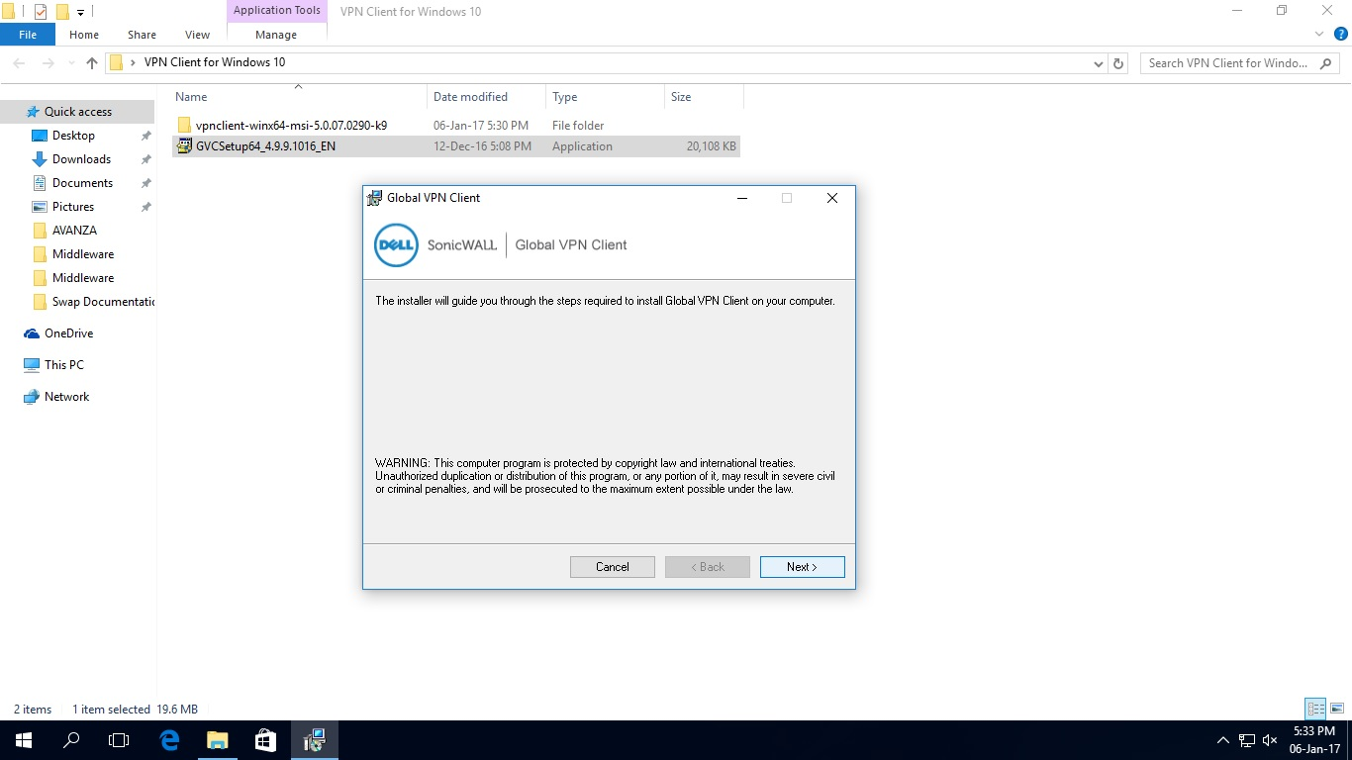

**Step # 2**: Double Click on GVCSetup64_4.9.9.1016_EN

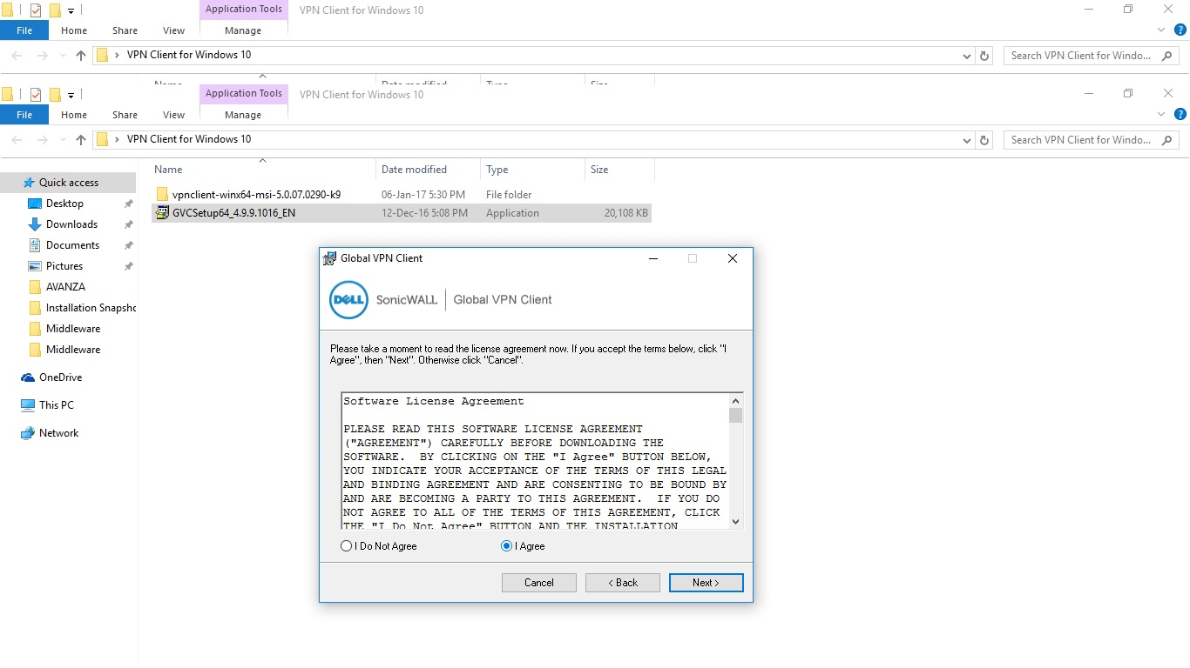

Step # 3: Click on Everyone and click on Next

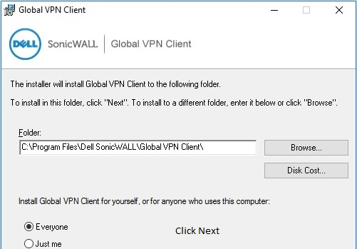

**Step # 4:** Click Next and Close when Installation is finished

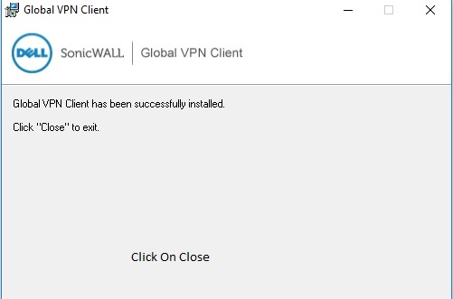

**Step # 5:** After Installation of first setup, please close the program by clicking on cancel and close.

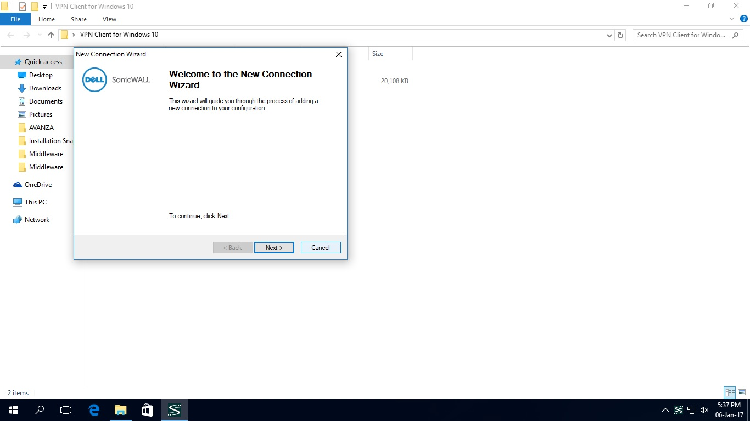

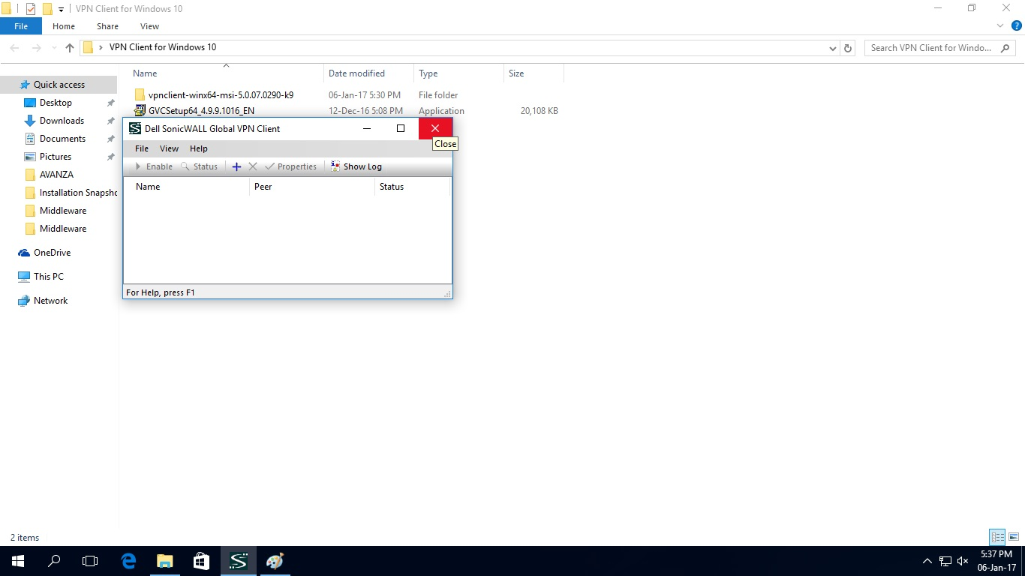

**Step # 6:** Now open vpnclient-winx64-msi-5.0.07.0290-k9 folder and double click on vpnclient_setup.

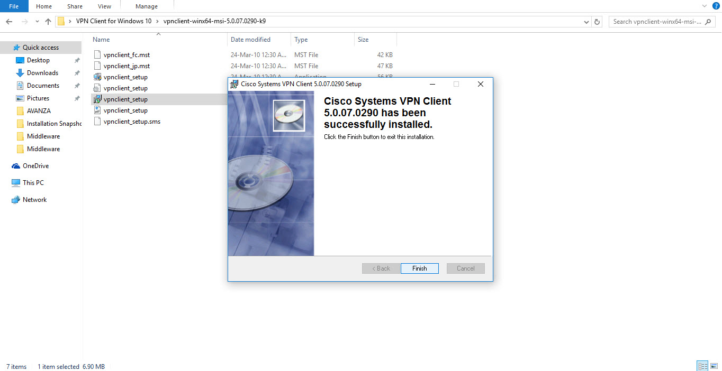

**Step # 7:** Click on I accept the agreement and click on Next.

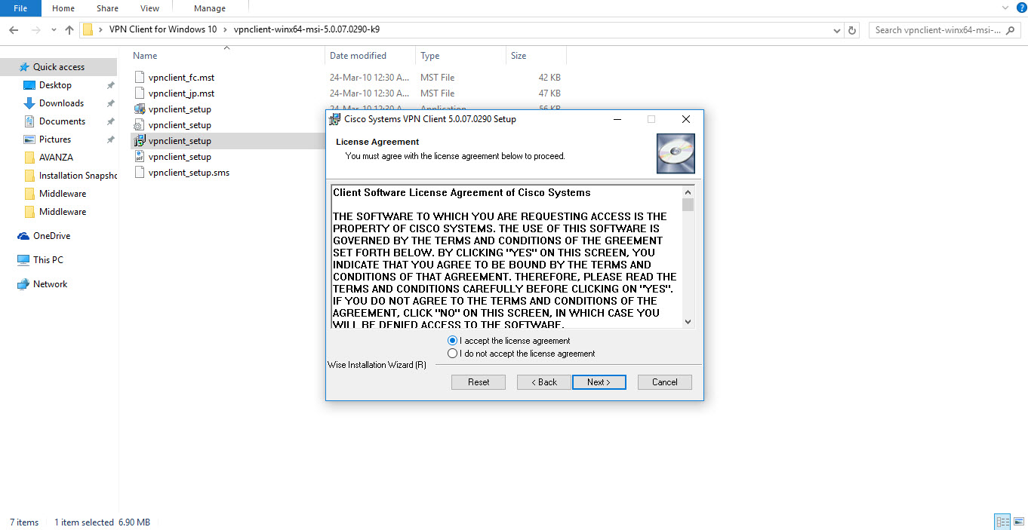

Step # 8: Proceed with Next commands and click on finish when Installation Completes.



**Step # 9**: Next step is to add route. Open the Route add bat file and right click on the file and click on Run as administrator. It will automatically add routes to your computer

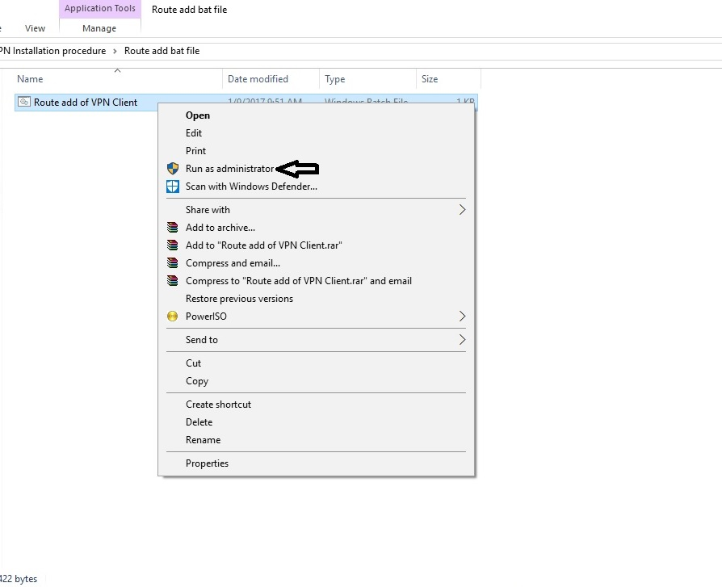

**Step # 10**: Please verify the Installation by clicking on start button.

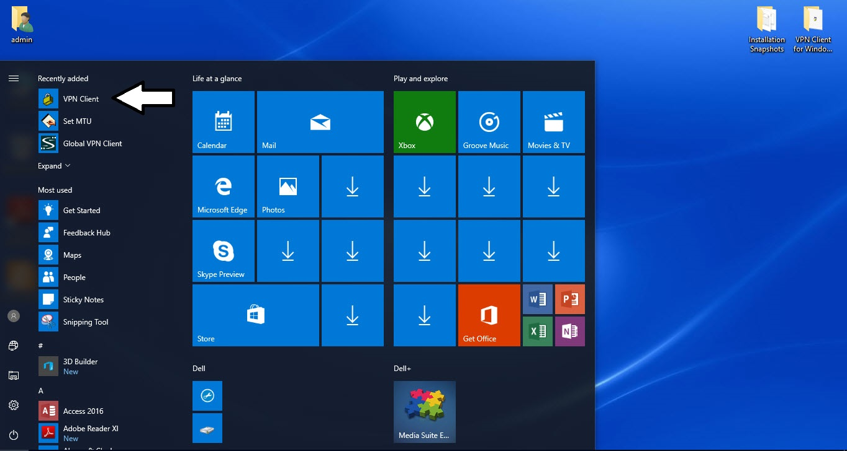

**Step # 11:** Now Open the VPN Client to configure new vpn connections. Click on New button and configure IP address and other settings from below snapshot for Internet VPN.

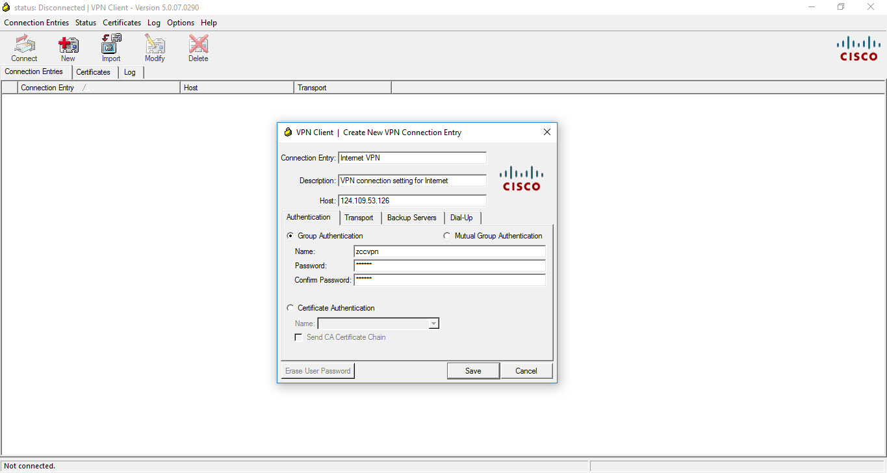

**Step # 12:** Click on New button and configure IP address and other settings from below snapshot for VPDN connection

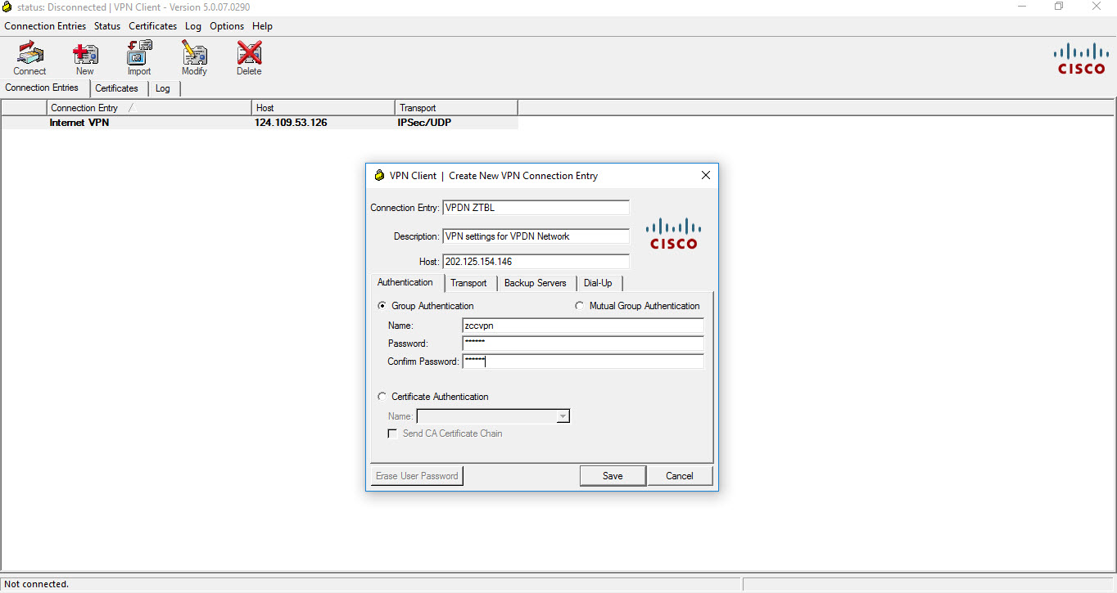

**Step # 13:** Now Click on Internet VPN if connection is on Internet and click on connect. It will connect to Head Office and you can surf through applications as required.

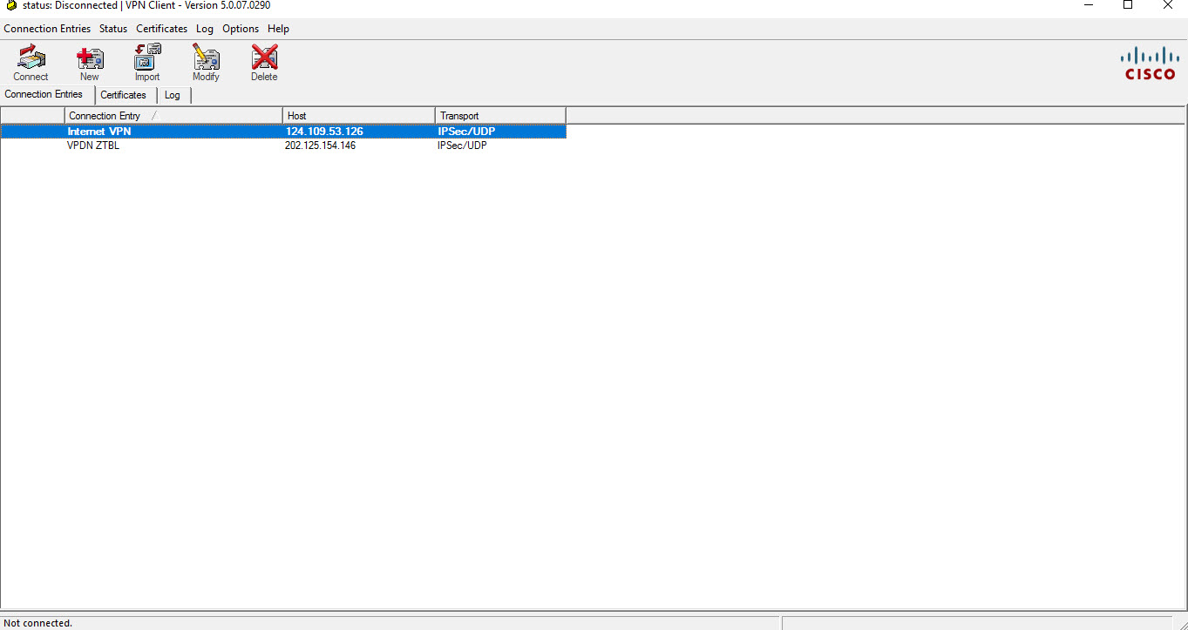

**Note**: Sometime Error 442 occurs when connecting to the VPN on Windows 10.

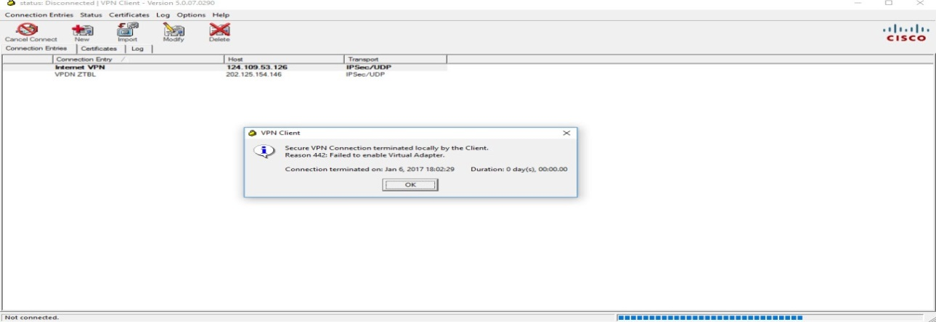

**Steps for resolution**: Please follow the Instructions in below snapshot. After below activity go to VPN client and click connect for Head Office connectivity.

